Detail for type of transaction

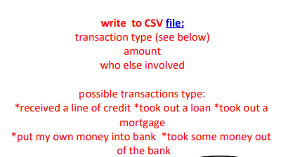

NEW possible transaction types:
*put money in bank
*took money out of bank
*got a loan
*received a line of credit
*took out a mortgage
*paid a loan
* bought a machine
*bought a vehicle
*bought real estate
*bought furniture
*bought a copier
*bought a computer
*bought tools or equipment
*paid a personal expense

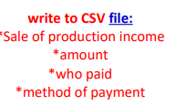
NEW method of payment types:
*cash

*credit card
*Visa
*master card
*American express
*discover
*Venmo
*Paypal
*check
*cashiers check
*square
*merchant one
*clover
*apple pay
*ACH
*debit card
*google pay
*cash app
*echeck
*stripe

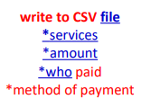
NEW method of payment types:
*see “sale of product” method types

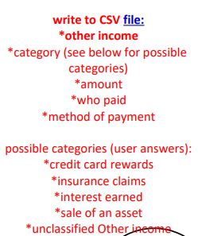

NEW possible categories:
*sold an asset (machine, furniture, real estate, etc)
* earned interest
* received dividend
*received credit card rewards
*got refund of expense
*got some other type of income
*got a tax refund
*got income from a partnership or LLC
*

